1i) 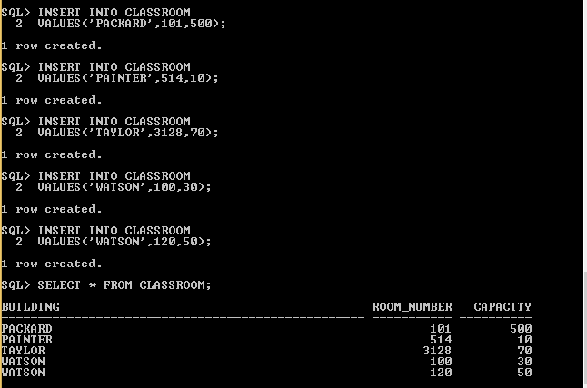

II)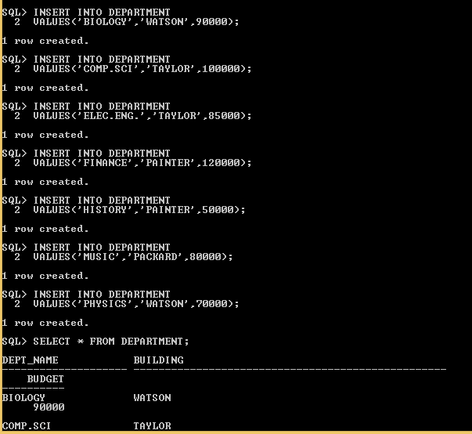

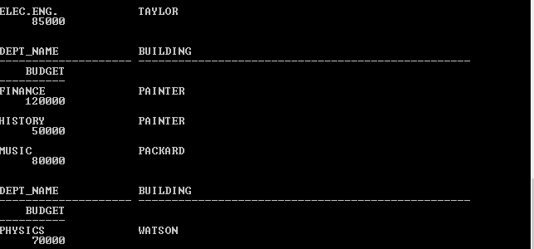

iii)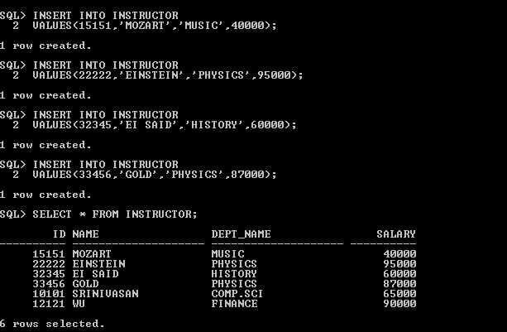

iv)

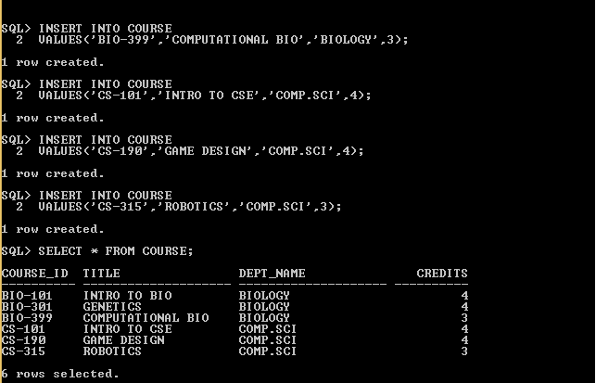

v)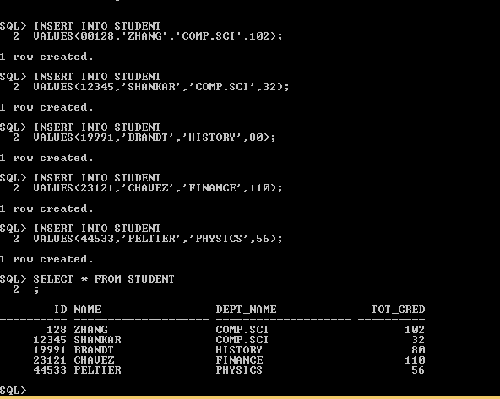

vi)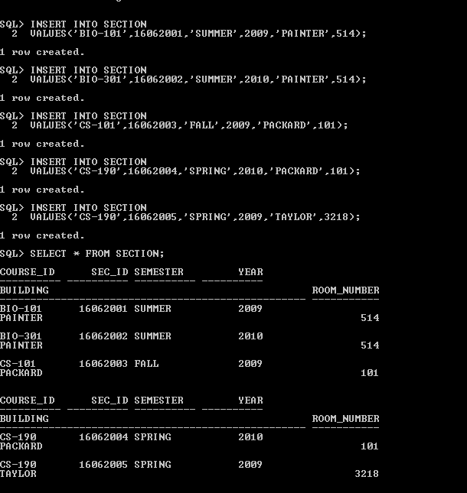

vii)SQL> INSERT INTO TAKES

2 VALUES(00128,'CS-101',16062003,'FALL',2009,'A');

1 row created.

SQL> INSERT INTO TAKES

2 VALUES(12345,'CS-190',16062005,'SPRING',2009,'A-');

1 row created.

SQL> INSERT INTO TAKES

2 VALUES(98988,'BIO-101',16062001,'SUMMER',2009,'A');

1 row created.

SQL> SELECT * FROM TAKES;

ID COURSE_ID SEC_ID SEMESTER YEAR GRADE

---------- ---------- ---------- ---------- ---------- -----

128 CS-101 16062003 FALL 2009 A

12345 CS-190 16062005 SPRING 2009 A-

98988 BIO-101 16062001 SUMMER 2009 A

2. a)UPDATE STUDENT

SET NAME=’MOZART’

WHERE ID=44533;

SQL> SELECT * FROM STUDENT;

ID NAME DEPT_NAME TOT_CRED

---------- -------------------- -------------------- ----------

128 ZHANG COMP.SCI 102

12345 SHANKAR COMP.SCI 32

19991 BRANDT HISTORY 80

23121 CHAVEZ FINANCE 110

44533 PELTIER PHYSICS 56

45678 MOZART PHYSICS 46

b)SQL> UPDATE DEPARTMENT

2 SET BUDGET=100000,BUILDING='TAYLOR'

3 WHERE DEPT_NAME='HISTORY';

1 row updated.

SQL> SELECT * FROM DEPARTMENT;

DEPT_NAME BUILDING

-------------------- --------------------------------------------------

BUDGET

----------

BIOLOGY WATSON

90000

COMP.SCI TAYLOR

100000

ELEC.ENG. TAYLOR

85000

DEPT_NAME BUILDING

-------------------- --------------------------------------------------

BUDGET

----------

FINANCE PAINTER

120000

HISTORY TAYLOR

100000

MUSIC PACKARD

80000

DEPT_NAME BUILDING

-------------------- --------------------------------------------------

BUDGET

----------

PHYSICS WATSON

70000

c)

SQL> UPDATE INSTRUCTOR

2 SET SALARY=SALARY*1.1;

6 rows updated.

SQL> SELECT * FROM INSTRUCTOR;

ID NAME DEPT_NAME SALARY

---------- -------------------- -------------------- ----------

15151 MOZART MUSIC 44000

22222 EINSTEIN PHYSICS 104500

32345 EI SAID HISTORY 66000

33456 GOLD PHYSICS 95700

10101 SRINIVASAN COMP.SCI 71500

12121 WU FINANCE 99000

d) SQL> UPDATE COURSE

2 SET CREDITS=4

3 WHERE DEPT_NAME='COMP.SCI';

3 rows updated.

SQL> SELECT * FROM COURSE;

COURSE_ID TITLE DEPT_NAME CREDITS

---------- -------------------- -------------------- ----------

BIO-101 INTRO TO BIO BIOLOGY 4

BIO-301 GENETICS BIOLOGY 4

BIO-399 COMPUTATIONAL BIO BIOLOGY 3

CS-101 INTRO TO CSE COMP.SCI 4

CS-190 GAME DESIGN COMP.SCI 4

CS-315 ROBOTICS COMP.SCI 4

e) SQL> UPDATE STUDENT

2 SET TOT_CRED=TOT_CRED+1

3 WHERE TOT_CRED BETWEEN 20 AND 50;

2 rows updated.

SQL> SELECT * FROM STUDENT;

ID NAME DEPT_NAME TOT_CRED

---------- -------------------- -------------------- ----------

128 ZHANG COMP.SCI 102

12345 SHANKAR COMP.SCI 33

19991 BRANDT HISTORY 80

23121 CHAVEZ FINANCE 110

44533 PELTIER PHYSICS 56

45678 MOZART PHYSICS 47

f) SQL> UPDATE INSTRUCTOR

2 SET SALARY=SALARY*1.05

3 WHERE SALARY<(SELECT AVG(SALARY)FROM INSTRUCTOR);

3 rows updated.

SQL> SELECT * FROM INSTRUCTOR;

ID NAME DEPT_NAME SALARY

---------- -------------------- -------------------- ----------

15151 MOZART MUSIC 46200

22222 EINSTEIN PHYSICS 104500

32345 EI SAID HISTORY 69300

33456 GOLD PHYSICS 95700

10101 SRINIVASAN COMP.SCI 75075

12121 WU FINANCE 99000

g) SQL> UPDATE TEACHES

2 SET YEAR=2010

3 WHERE COURSE_ID='CS-101' AND SEMESTER='FALL';

1 row updated.

SQL> SELECT * FROM TEACHES;

ID COURSE_ID SEC_ID SEMESTER YEAR

---------- ---------- ---------- ---------- ----------

76766 BIO-101 16062001 SUMMER 2009

76766 BIO-301 16062002 SUMMER 2010

10101 CS-101 16062003 FALL 2010

10101 CS-347 16062004 FALL 2009

45565 CS-101 16062005 SPRING 2009

3)

SQL> DELETE FROM STUDENT

2 WHERE TOT_CRED=0;

1 row deleted.

SQL> SELECT * FROM STUDENT;

ID NAME DEPT_NAME TOT_CRED

---------- -------------------- -------------------- ----------

128 ZHANG COMP.SCI 102

12345 SHANKAR COMP.SCI 33

19991 BRANDT HISTORY 80

23121 CHAVEZ FINANCE 110

44533 PELTIER PHYSICS 56

45678 MOZART PHYSICS 47

4)

SQL> DELETE FROM INSTRUCTOR

2 WHERE ID LIKE '765%';

1 row deleted.

SQL> SELECT * FROM INSTRUCTOR;

ID NAME DEPT_NAME SALARY

---------- -------------------- -------------------- ----------

15151 MOZART MUSIC 46200

22222 EINSTEIN PHYSICS 104500

32345 EI SAID HISTORY 69300

33456 GOLD PHYSICS 95700

10101 SRINIVASAN COMP.SCI 75075

12121 WU FINANCE 99000

5) SQL> DELETE FROM COURSE

2 WHERE COURSE_ID NOT IN(SELECT COURSE_ID FROM SECTION);

3 rows deleted.

SQL> SELECT * FROM COURSE;

COURSE_ID TITLE DEPT_NAME CREDITS

---------- -------------------- -------------------- ----------

BIO-101 INTRO TO BIO BIOLOGY 4

BIO-301 GENETICS BIOLOGY 4

CS-101 INTRO TO CSE COMP.SCI 4